3D Weather in the Classroom

**El Nino/ La Nina Weather Impacts**

1. **Overview**

When El Niño or La Niña arrives, it causes an impact for the United States. The most notable impact is the shift in the path of the jet stream. The jet stream separates the Polar Cell and the Ferrell Cell (the cold air mass and the warm air mass).

Because El Niño and La Niña are opposite phases of El Niño-Southern Oscillation (ENSO) that swings back and forth every 3-10 years, the phases alternate between warm and cool large areas of the tropical Pacific.

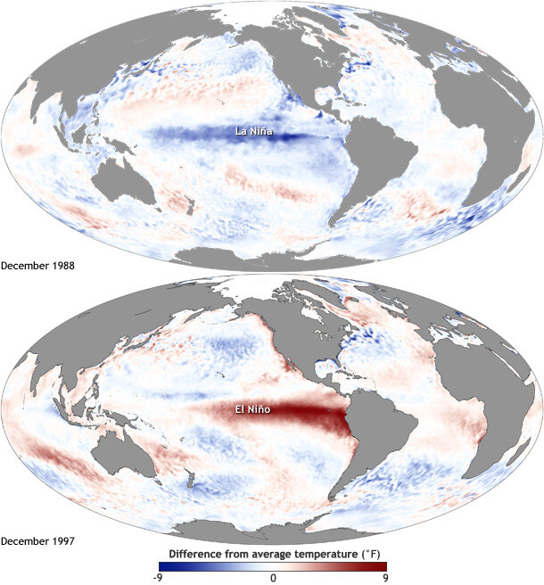

Figure 1. Average sea surface temperature during La Nina (top) and El Nino (bottom).

**Did you know?**

La Niña means Little Girl in Spanish. La Niña is also sometimes called El Viejo, anti-El Niño, or simply "a cold event." During La Niña events, trade winds are even stronger than usual, pushing more warm water toward Asia. Off the west coast of the Americas, upwelling increases, bringing cold, nutrient-rich water to the surface.

El Niño means Little Boy, or Christ Child in Spanish. South American fishermen first noticed periods of unusually warm water in the Pacific Ocean in the 1600s. The full name they used was El Niño de Navidad because El Niño typically peaks around December.

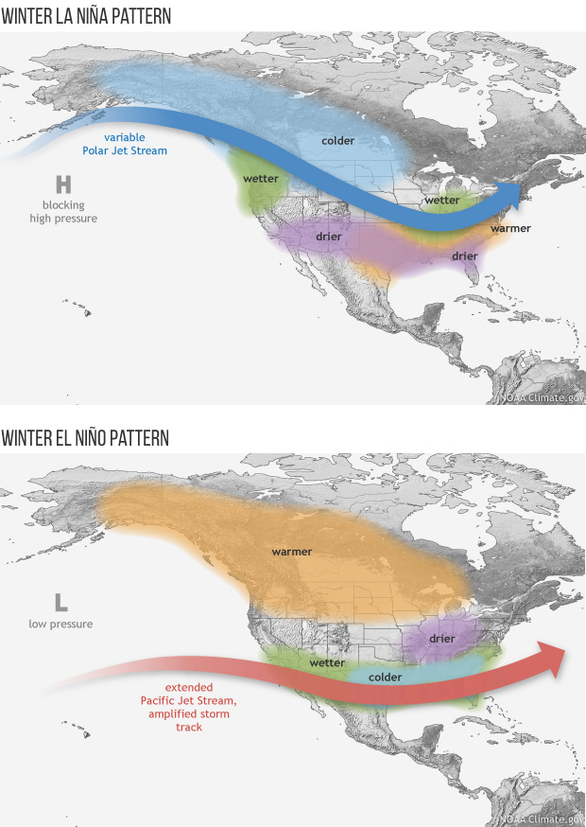

Figure 2. The winter weather associated with La Nina.

During La Niña, the Pacific jet stream moves further North and is less common across the southern region of the United States (Figure 1). Alaska to the Pacific Northwest tends to be wetter and cooler than average, and the southern region of the United States (from the West Coast to the East Coast) tends to be warmer and drier than average.



Figure 3. The winter weather associated with El Nino.

During El Niño, the Pacific jet stream is further South and brings a different impact to the United States. Alaska, Canada, and the northern United States are warmer than average (Figure 2). The southern United States (from the West Coast to the East Coast) is wetter and colder than average.

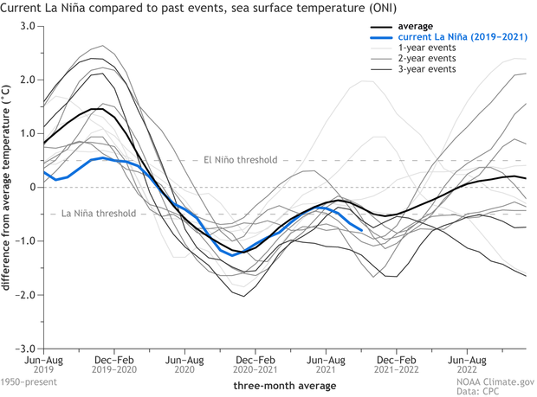

Figure 4. The thresholds of La Nina and El Nino.

El Niño and La Niña can cause different weather patterns, how warm or cold it is, depending on where the jet stream falls during the winter season. Currently for the 2021-2022 winter season, La Niña is in effect, and because of this, the southern region of the United States is not receiving a very cold winter (Figure 4).

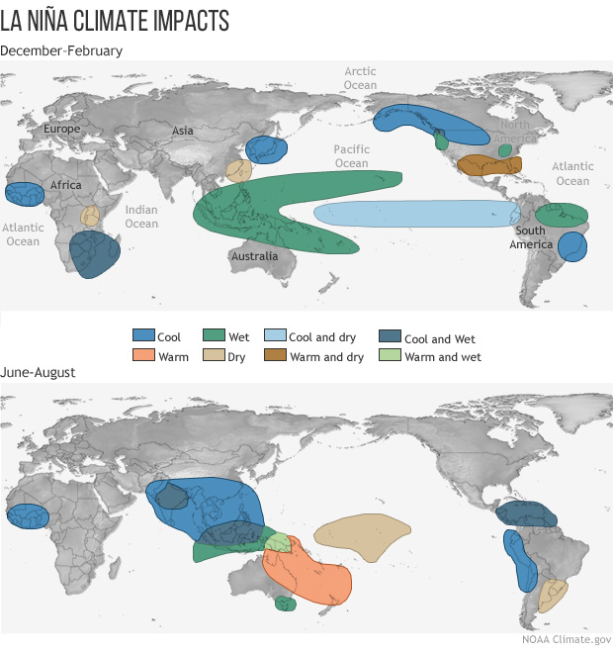

Figure 5. The impacts on the climate due to La Nina.

El Niño and La Niña can also impact different areas of the world. The United States may be dry and warmer than average, but other places in the world tend to be cooler or wetter. La Niña is often associated with wet conditions in eastern Australia, and with heavy rainfall in Indonesia, the Philippines and Thailand (Figure 5). Drier than normal conditions are generally observed along coastal Ecuador and Northwestern Peru.

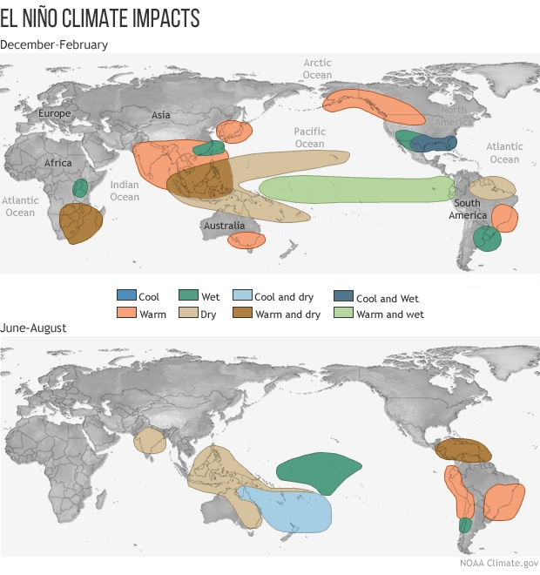

Figure 5. The impacts on the climate due to El Nino.

El Niño is often associated with warm and dry conditions in southern and eastern inland areas of Australia, as well as Indonesia, the Philippines, Malaysia, and central Pacific islands such as Fiji Papua New Guinea (Figure 5). Wetter than normal conditions are typically observed along the Gulf Coast of the United States, the west coast of tropical South America (Colombia, Ecuador, and Peru) and from southern Brazil to central Argentina. Parts of eastern Africa (Kenya, Uganda) also usually receive above-normal rainfall.

El Niño-Southern Oscillation (ENSO) is one of the most important climate phenomena on Earth due to its ability to change the atmospheric circulation of the globe. This change in the global atmospheric circulation influences temperature and precipitation across the globe. ENSO is also important climate experts and meteorologists can often predict its arrival multiple seasons before it arrives.

1. **IDV Project**

* Project filename: “La Nina.xidv” and “El Nino.xidv”
* Project data:
* Filename: “gfsanl_3_20160101_0000_000.grb, gfsanl_3_20171226_0000_000.grb2”
* 0.25°x0.25° Global Forecast System (GFS) analysis data for January 1, 2016 (El Nino) @ 00:00Z and December 26, 2017 (La Nina) @ 00:00Z.

El Nino

* Displays:
* Maps
* World country outlines.
* Imagery
  + - * Temperature surface
* Flow Displays
  + - * True Wind Vectors
    - Plan View
      * Relative Humidity

La Nina

* Displays:
  + Maps
    - World country outlines
  + Imagery
    - Temperature surface
  + Flow Displays
    - True Wind Vectors
  + Plan View
    - Relative Humidity
* Features to note:
  + Figure 6. Shows the relative humidity of the United States from January 1st of 2016 during an El Nino oscillation. You can see dry conditions along the southern regions of the United States (like the southwest and southeast). However, some areas will have more moisture in the Southeast U.S. due to proximity to the Gulf of Mexico. Not all ENSO events are the exact same as in the examples.
  + Figure 7. Shows the relative humidity of the United State from December 26th, 2017, during a la Nina oscillation. The southern region of the United States is much drier compared to the effects of the El Nino (Figure 1).
  + Figure 8. The temperatures along the southern edge of the United States are cooler than average.
  + Figure 9. The jet stream on this specific date reached lower latitudes allowing temperatures to be even cooler than EL Nino (Figure 3).
  + Figure 10. IDV imagery shows wind speed on January 1st, 2016, during El Nino. The strong low pressure just south of Alaska keeps the fronts weaker.
  + Figure 11. IDV Imagery showing wind speed on December 26th, 2017, during La Nina. Strong high pressure keeps the jet stream further North. This leaves the South warmer and drier.

EL NINO

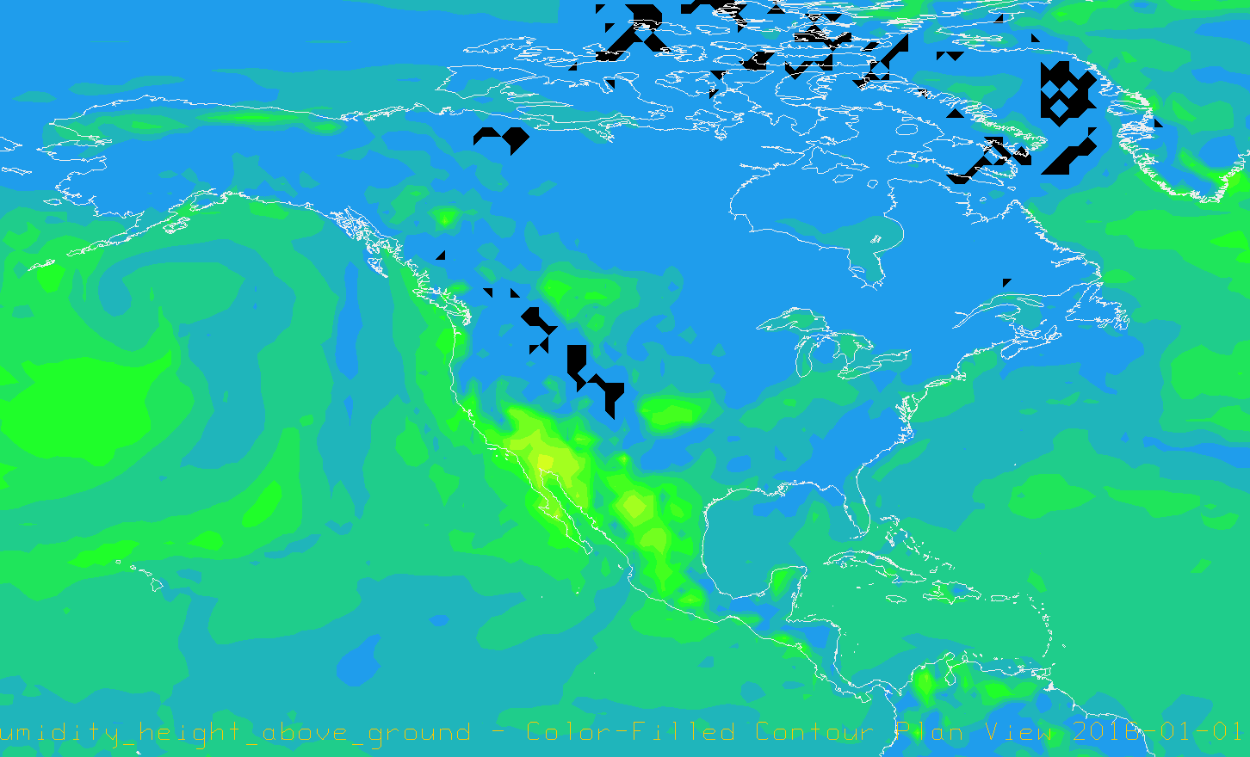

Figure 6. IDV imagery displays relative humidity on January 1st, 2016, over the United States during an El Nino oscillation.

Figure 7. IDV imagery displays relative humidity on December 26th, 2017, over the United States during an La Nina oscillation.

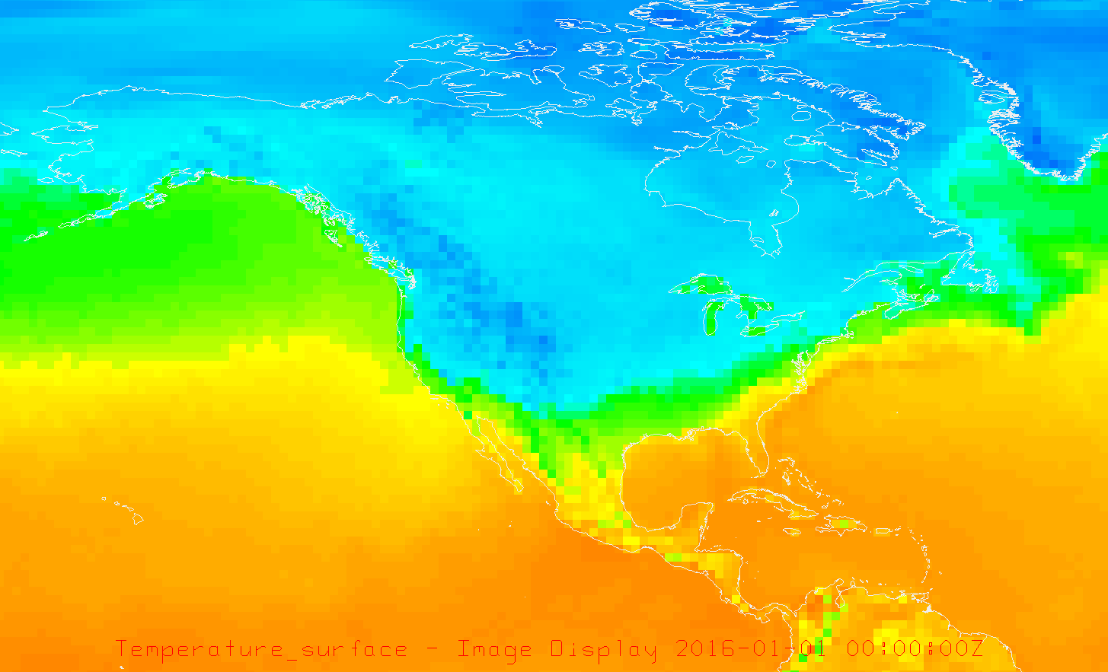

Figure 8. IDV Image showing surface temperature for the United States on January 1st, 2016, during an El Nino oscillation.

Figure 9. IDV image showing surface temperature for the United States on December 26th, 2016, during an La Nina oscillation.

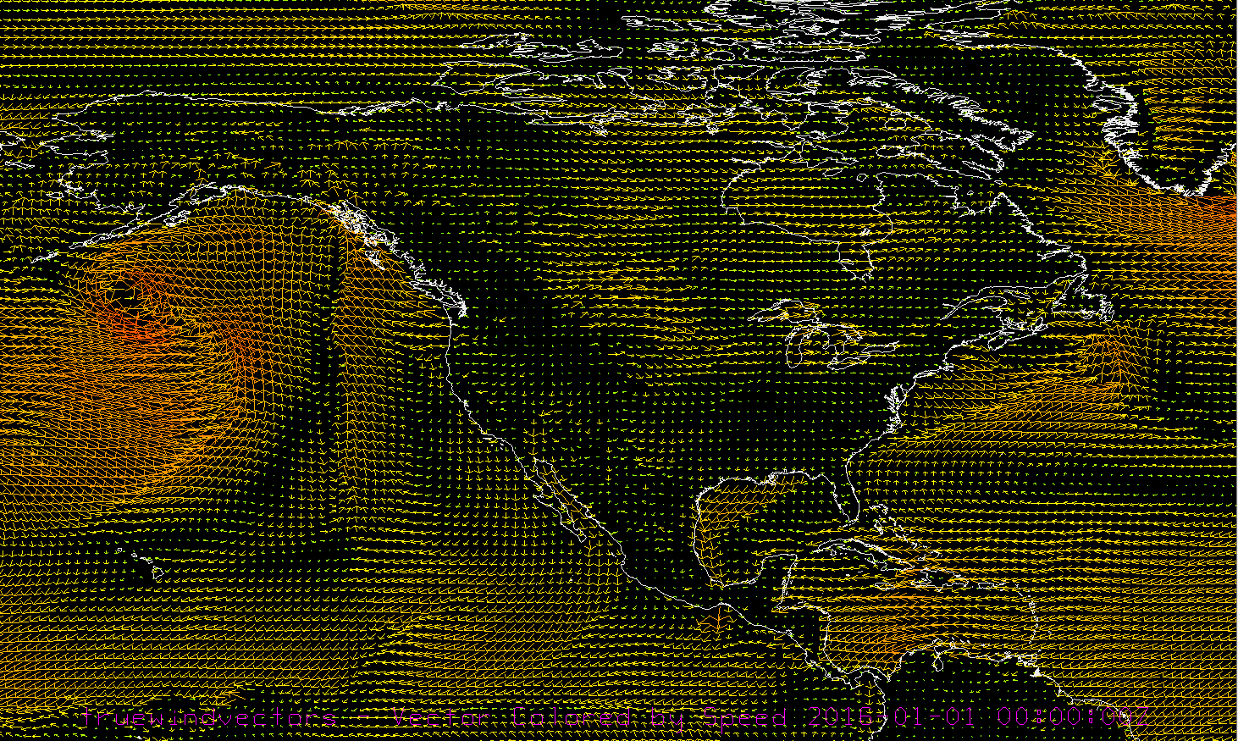

Figure 10. IDV imagery shows wind speed on January 1st, 2016 during El Nino. te strong low pressure just south of Alaska keeps the fronts weaker.

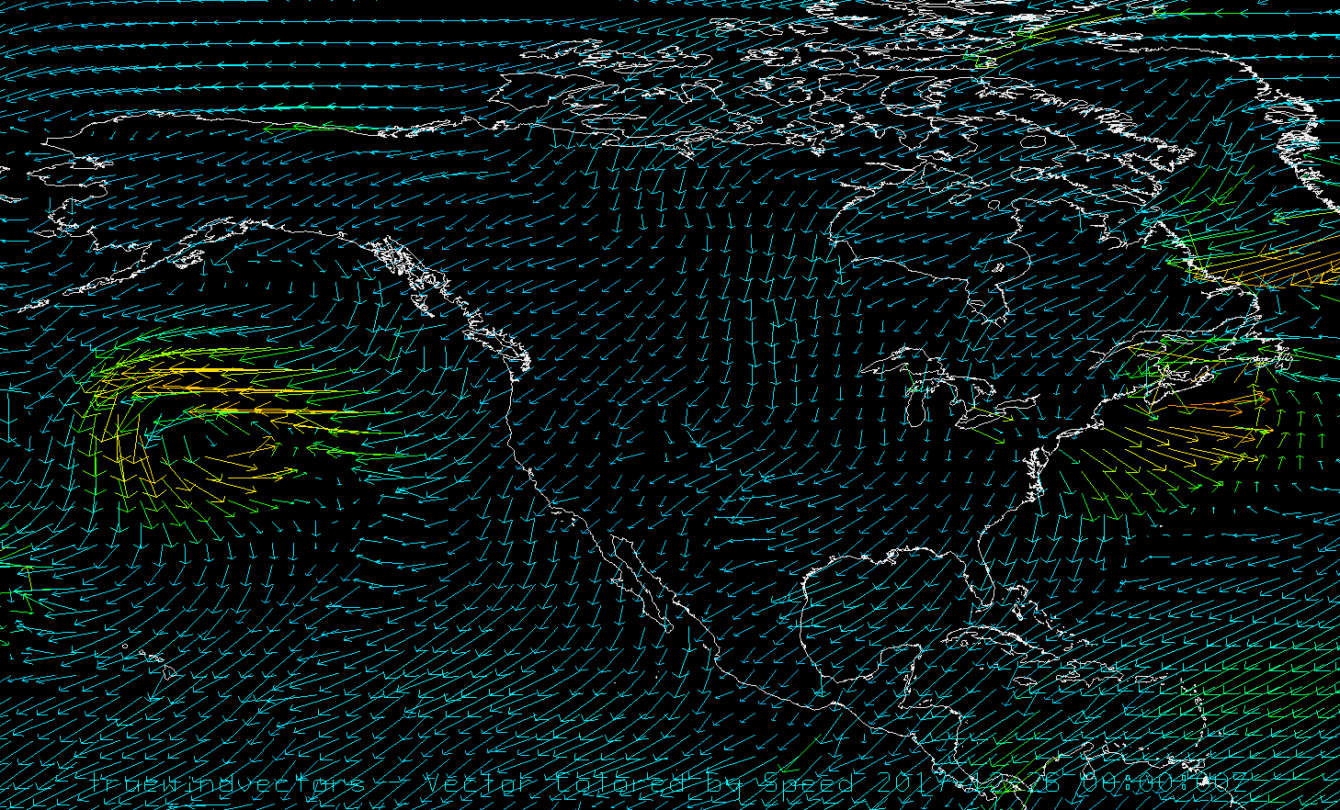

Figure 11. IDV Imagery showing wind speed on December 26th, 2017, during La Nina.

Knowledge Requirements

- Module 1.2 Daily and Seasonal Temperature Patterns

- Module 3.3 Measurements of Moisture

- Module 6.4 El Nino/ La Nina

- Module 5.2 Wind and Pressure

Knowledge Test

1. What conditions does El Nino bring to the Southern U.S. (from west to east coast)?

(A) Warmer and drier than average

**(B) Cooler and wetter than average**

(C) Warmer and wetter than average

(D) Cooler and drier than average

2. What conditions does La Nina bring to the Southern U.S.?

**(A) Warmer and drier than average**

(B) Cooler and wetter than average

(C) Warmer and wetter than average

(D) Cooler and drier than average

3. During El Niño, the Pacific jet stream is further _______.

**(A) South**

(B) North

(C) East

(D) West

4. What was in effect during the 2021-2022 season?

**(A) El Nino**

(B) La Nina

5. During La Niña, the Pacific jet stream moves further ______.

(A) South

**(B) North**

(C) East

(D) West

6. La Niña is often associated with ______ conditions in eastern Australia.

**(A) Wet**

(D) Dry

(C) Suny

(D) Colder